Numeric Overflows

Kenneth J Gollaher

CS-405 Secure Coding, Southern New Hampshire

Module 1-3: Numeric Overflow Coding

Professor Ivan Gappy

Sept 4th, 2022

**Overflow Tests**

**Underflow Tests**

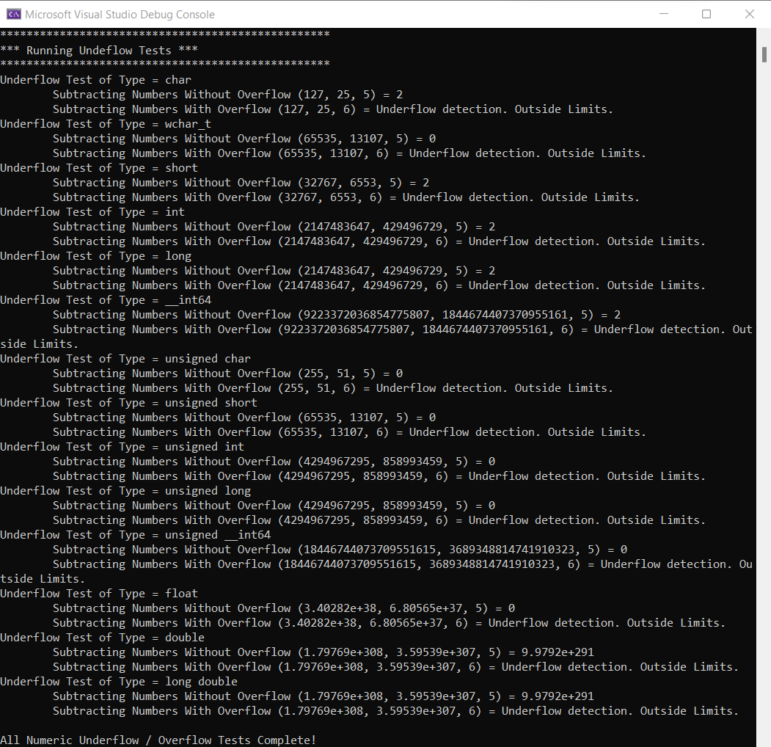

I have added if-else statements for when the overflow or underflow has occurred. For the add_number function I find the max value of the data type using the numeric_limits::max() function By subtracting the increment from the maximumLimit to find the limit that it can increment to before causing an overflow message to be displayed. If that limit is crossed, then I return with a value, which displays a message that an overflow has occurred. The subtract_numbers are a similar process to the add_numbers. I find the lowest value for each data and then add the decrement to find this functions limit. If the limit is crossed the value is returned and an underflow message will be displayed. Overall, this process was straightforward once I got my bearings in order.